Subject

* Has a list of Observers









**Come up with a possible subject and observer relationship.**

There are many different possible examples, but you could have said an auction and bidder, or news broadcast and viewer. These are examples of the observer design pattern. In each of these, relationships are generally one subject to many observers. One auction is observed by many bidders. One broadcast is observed by many viewers.

2 major roles

* Subject
  + Eg. blog
* Observer
  + Eg. subscribers

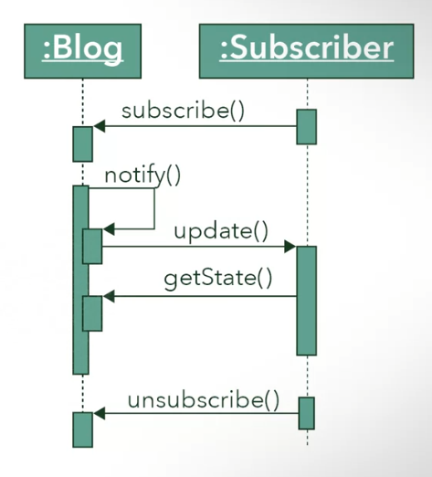



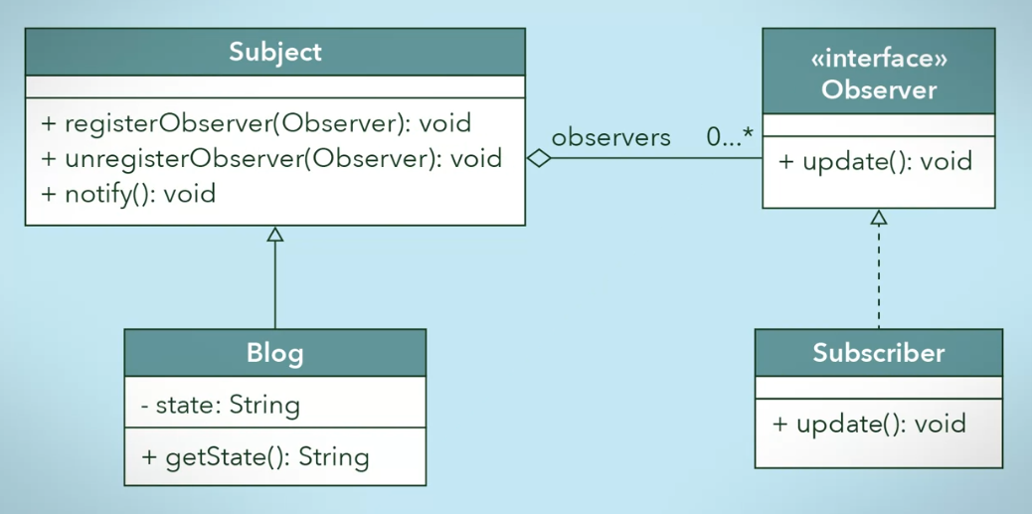

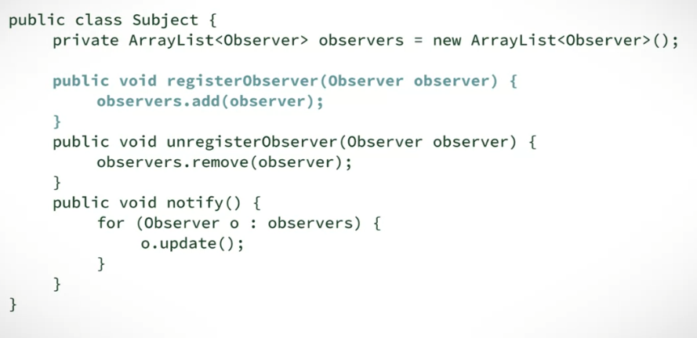

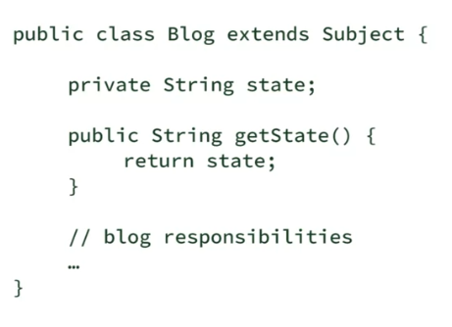



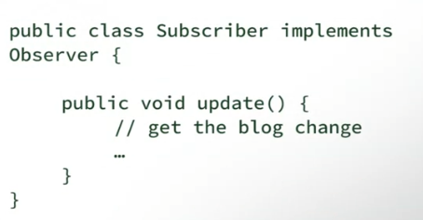

**Choose the correct UML for an observer design pattern between an auction and bidders.**

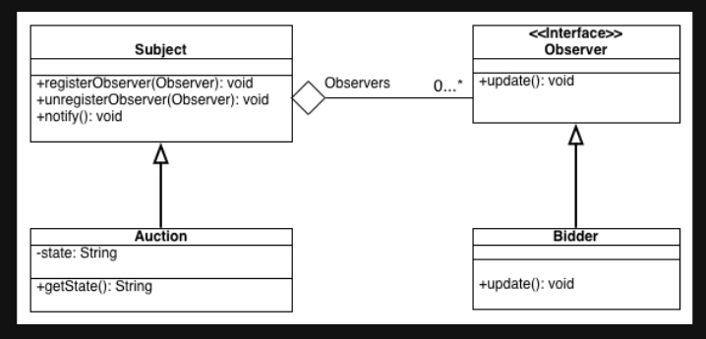

Great job! B shows that there is often more than one observer for each subject, and that the Observer has a method to update itself!

Answer A assumes that there is only one bidder for an auction. That would make for a very lonely auction.

Answer C assumes that the Bidder class does not have to implement the update method in the Observer interface, which is incorrect.

Answer D is missing the notify method, so that an auction can notify its bidders.

